37. Develop a system using UML for Doctor Appointment System. The central system should manage doctors’ availability and appointments for the given date. The patient can book the doctor’s appointment based on the doctor’s availability. When the booking is confirmed, it should be updated with the patient and doctor.

**SEQUENCE:**

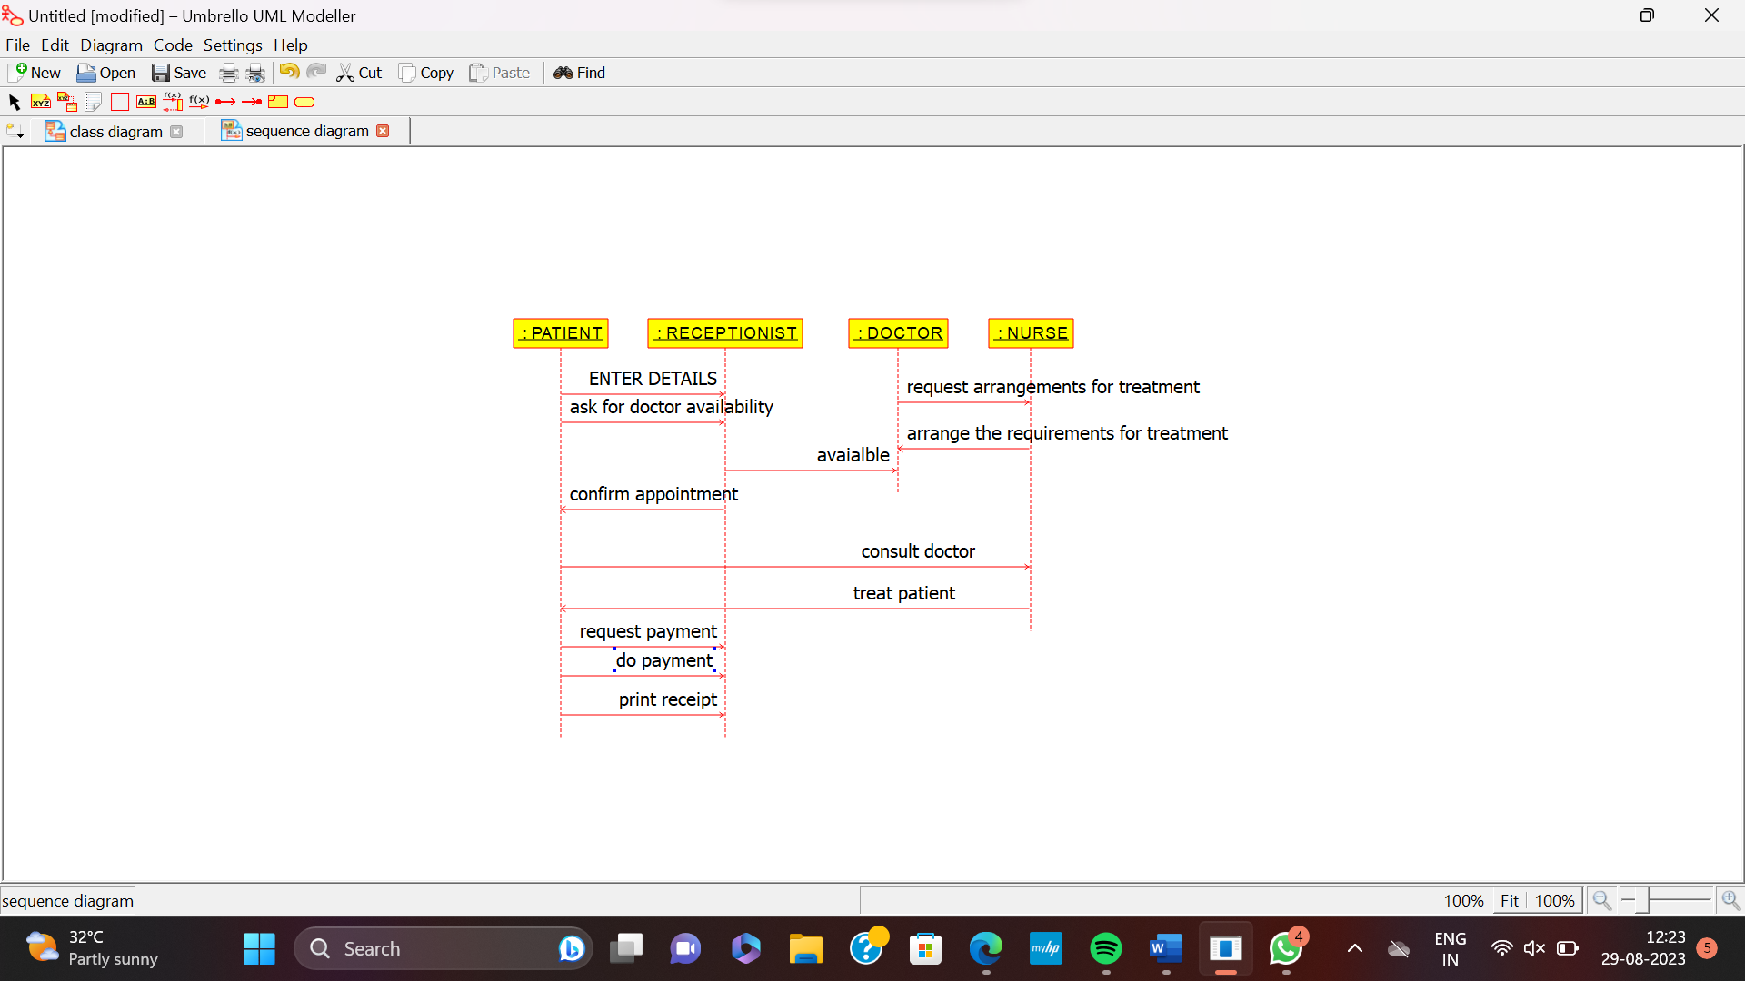

**USE CASE:**

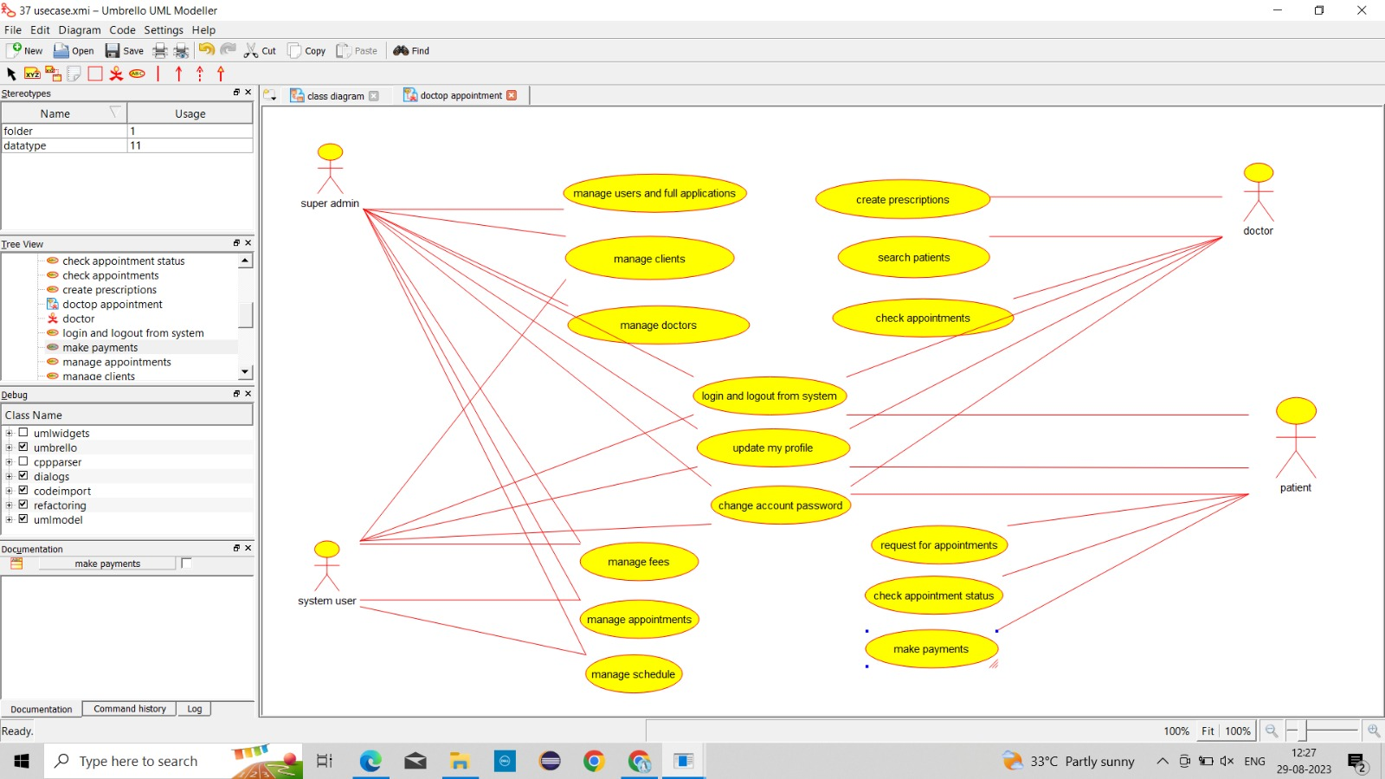

**ACTIVITY:**

